TABLEAU DATA VIZ HOMEWORK

1. Map the mobile subscription data in 1990 (the first year in the file) on the world map. Generate another map using 2016 data (the last year in the file). Briefly describe what you get by comparing these two maps.

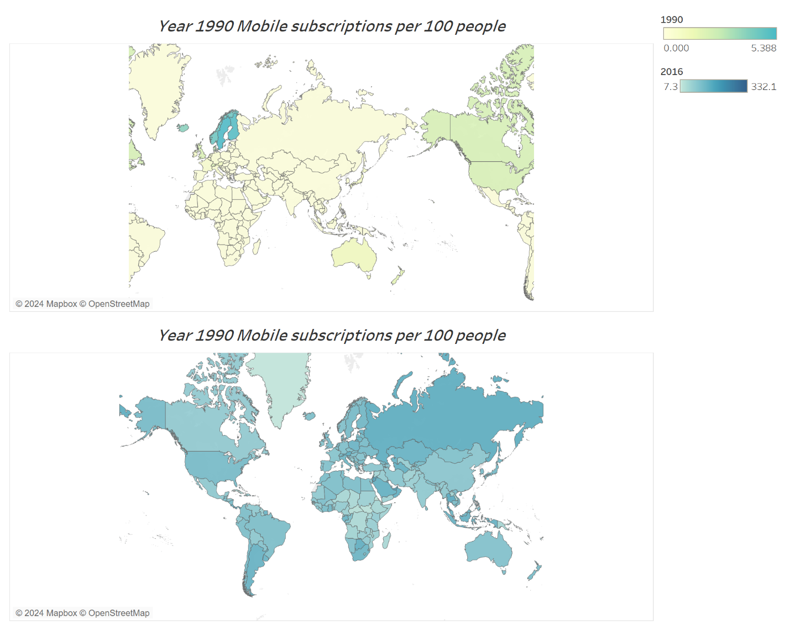

This initial map depicts the state of phone subscriptions in the year 1990 and uses a color gradient ranging from lime green to shades of blue to represent the density of subscribers across different countries/regions. The prevalence of lime green across most areas signifies that a substantial number of regions had little to no phone subscriptions at the time, which is further underscored by the fact that a multitude of countries were marked with a subscription rate of 0.000, indicating an absence of cellular connectivity. Notably, Sweden emerged as the leader in this era, boasting the highest phone subscription rate at 5.388 per 100 people. This stark contrast in subscription rates highlights the digital divide of the early '90s, where telecommunication infrastructure was a privilege enjoyed by a few, leaving the majority of countries in a state of technological isolation.

In the year 2016, which is on the second graph in the image above, there is a remarkable surge in mobile cellular subscriptions per 100 people is observed, a trend vividly represented by the transition of colors from light lime blue to a deeper blue on the graph, illustrating the substantial growth in subscription numbers. Analyzing the data visualizations further, it becomes apparent that Eritrea recorded the lowest rate of phone subscriptions per 100 individuals for that year. In stark contrast, Macao SAR, China, topped the chart with the highest subscription rate. When we consider the progression over time, a significant development is noted: while the lowest recorded number of phone subscriptions in 1990 was 0, as shown in the initial graph, by 2016, the minimum had climbed to at least 7.3, reflecting considerable advancements in telecommunications access and adoption even among the least connected countries.

1. Please find out the top five countries/regions with the highest mobile subscriptions per 100 people in 2016, display their names and values. Briefly describe how you find them.

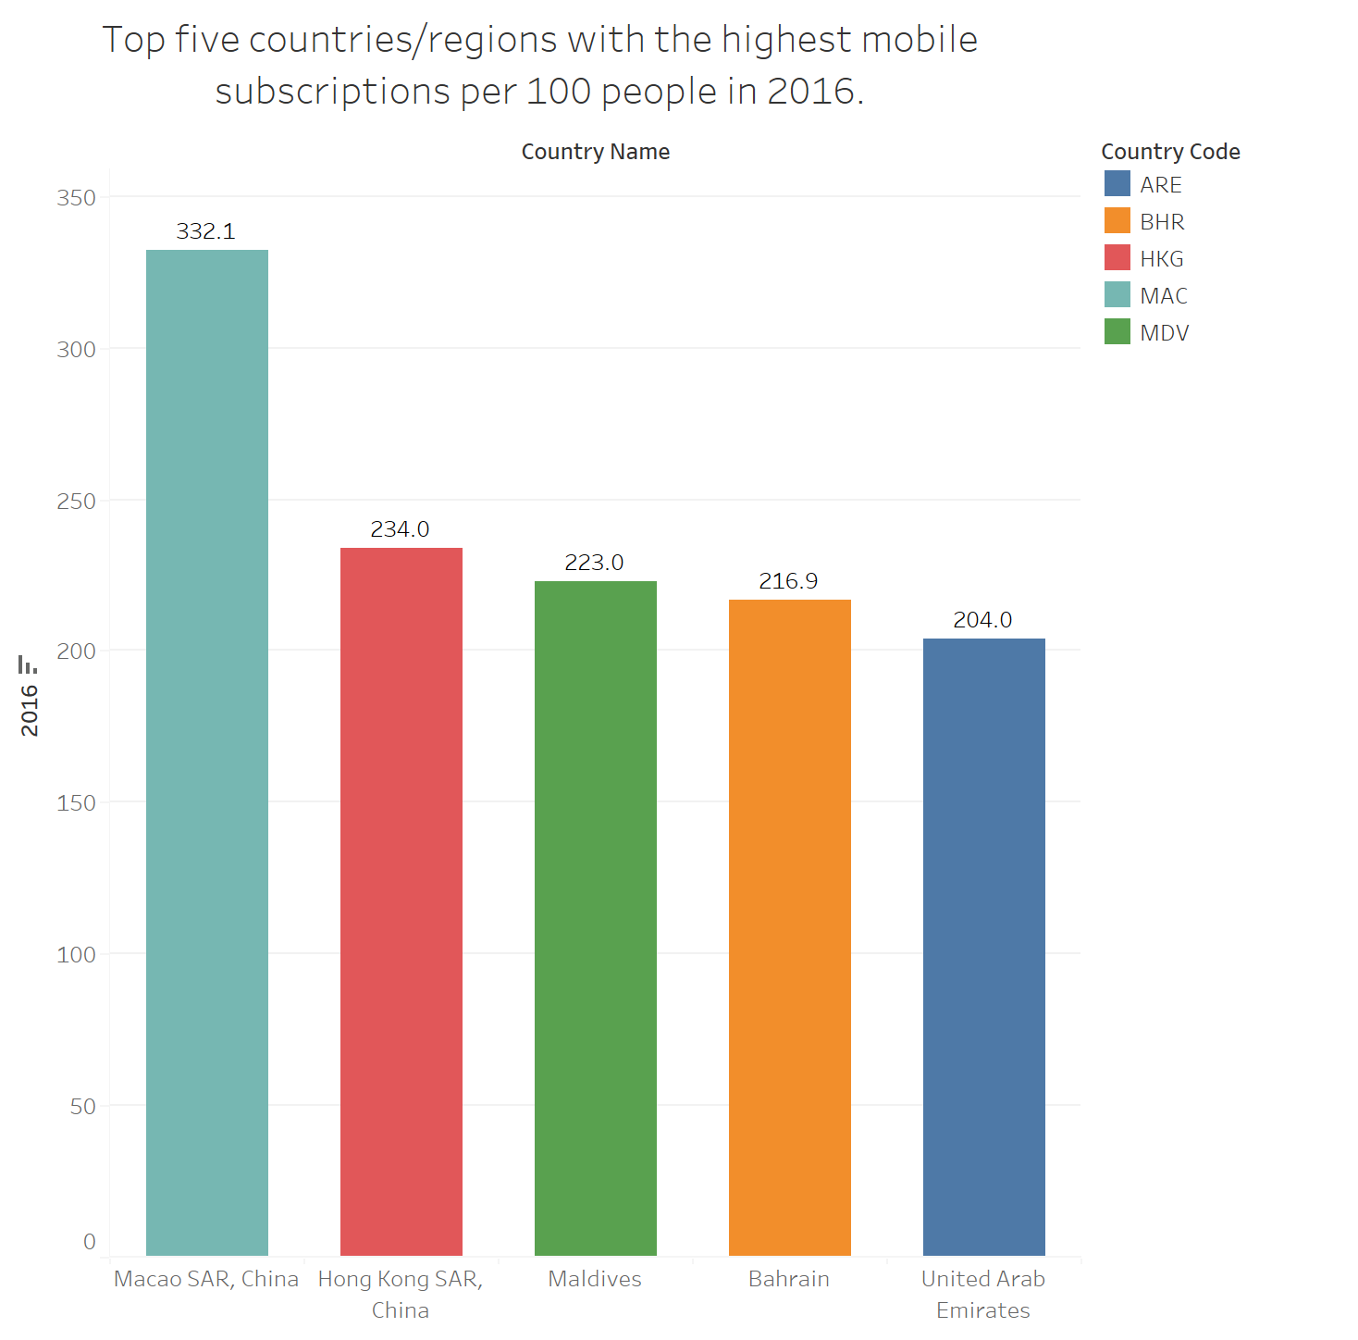

The graph above the top 5 countries with the highest number of phone subscriptions per 100 in 2016. Talking about how I found them I plotted year 2016 in the rows section of tableau and country name in the column section of tableau. The next step was to filter the countries to get the top 5.

To do that I dragged country name and clicked by fields and then chose top 5. For aesthetics, I again to the marks sections and dopped into color section. For labels I dragged sum to labels section so that the exact numbers of the countries

1. Zoom in these five countries/regions, plot these countries’ values from 2000 to 2016, to show the change of their values. Briefly describe the trend you observe. *note: without transforming the data, it would take a few more steps to draw trend lines (or line charts). Feel free to use other chart types to show the trend if you wish.

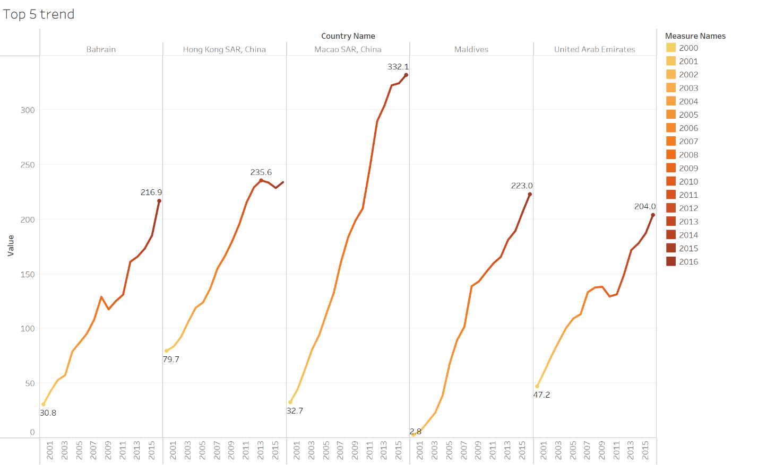

About the interpretation:

Bahrain shows a consistent increase over time, with some fluctuation but generally an upward trend.

Hong Kong SAR, China: There is significant growth with values peaking around 2013-2014, after which there is a slight dip.

Macao SAR, China: This region shows the most dramatic increase in values over time, with a very sharp rise up to 2014, and then it seems to plateau or slightly decrease after 2014. In the period of 16 years mobile subscribers increased more than 10 folds (from minimum of 32.7 to over 330 in 2016)

Maldives: The trend for Maldives is upward with a steady increase in value over the years, without any dramatic spikes or drops.

United Arab Emirates: The UAE shows growth over the period with a slight fluctuation but generally an increasing trend, although the increase is less steep compared to Macao SAR, China.

Each line segment for a country/region essentially tells the story of how that particular phone subscription has changed over 16 years, indicating the pace and pattern of development or growth within that metric for each country/region.

1. Repeat the above process for the bottom five countries/regions (exclude the countries/regions without data) with the least mobile subscriptions per 100 people in 2016, and describe their trends from 2000 to 2016.

On the graph showing the bottom 5, the data and values can be interpreted as follow:

Central African Republic: The number of phone subscribers per 100 people shows a gradual increase from 2000 until peaking around 2009 or 2010, after which there is a sharp decline.

Eritrea: There is an overall increase in the number of phone subscribers per 100 people, but the growth rate seems to be slow, and the data shows some fluctuations. There also seems to be missing data from 2001 to just about 2003

Korea, Democratic People's Republic: The data starts from 2002 and shows a very gradual increase. There's a notable jump around 2008, but the values remain relatively low compared to other countries.

Micronesia, Federated States: The graph indicates a steady increase in the number of phone subscribers per 100 people, with more significant growth starting around 2004 and continuing upwards.

South Sudan: Data for South Sudan begins in 2008, suggesting that prior records may not have been available, possibly due to the country's independence in 2011. There is a sharp increase in subscribers from the first year shown, peaking around 2012, followed by a decline.

1. Do you observe any differences by comparing the figures you generated for the top five and the bottom five?

The direct comparison between the top five and bottom five countries in terms of phone subscribers per 100 people based on the two charts provided shows distinct differences:

***Magnitude of Values:***

The top five countries exhibit much higher values, suggesting a greater number of phone subscribers per 100 people, which can be indicative of more developed telecommunications infrastructure and possibly higher economic development.

The bottom five countries have much lower values, indicating fewer subscribers per 100 people, suggesting limited access to telecommunications services.

***Trend Patterns:***

In the top five, the trends are generally upwards, with some countries showing rapid growth (like Macao SAR, China) and others showing consistent growth over the years.

The bottom five have slower growth trends, and some even show declines after certain points. The growth where present is less steep and more erratic.

***Consistency:***

The top five countries/regions show a more consistent upward trend across the years.

The bottom five display inconsistencies, with some years showing decreases or stagnation in the number of phone subscribers.

***Data Availability:***

The top five countries/regions have data consistently available from 2000 to 2016.

For the bottom five, some countries, like South Sudan, do not have data available for the entire range, possibly due to the lack of infrastructure or data collection mechanisms, or in the case of South Sudan, because it only became an independent country in 2011.